How to attach Template
- Click on the Document Template icon in the Quick access toolbar.
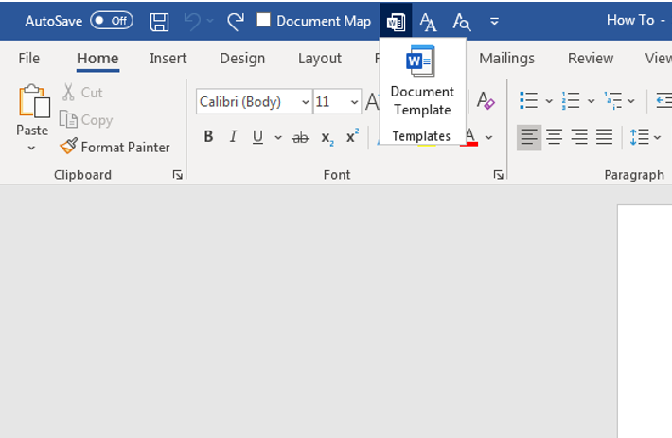
- Remove the items in the Checked items that are currently loaded. Then click on the Attach button and select the New_Template_Normal_Series template from the location you have saved it.
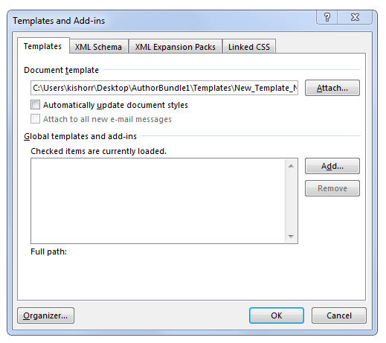
- Click on the Add button and add the New_Template_Normal_Series and 269_EditTools_new templates.
- Remember to check the Automatically update document styles option.
- Click on the OK button.
